From: Don

To: The Record

Subject: Hostek Configuration for BBSG BEFORE VPS

Date: 5/1/2015

Link to control panel: <https://wcp.hostek.com/Login.aspx>

After logging into Hostek Control Panel. In domain: uisdesign, Click on MySQL within Databases.

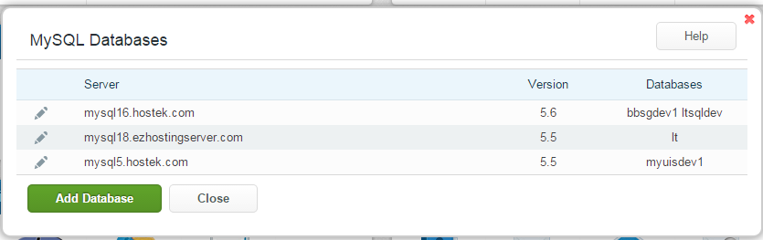

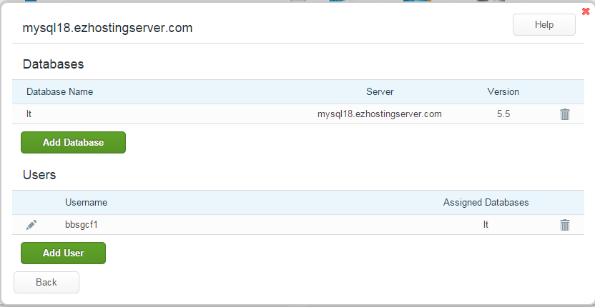

Lthostek is the development database Datasource in CF on hostek

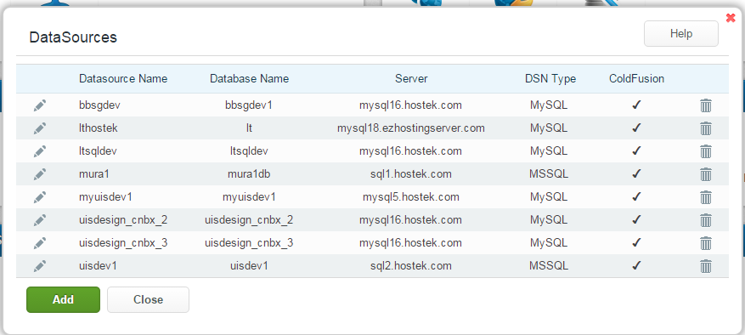

Here is link to development application, in a subdomain: <http://bbsgdv1.uisdesign.com/?fwreinit=1>

Here are subdomains

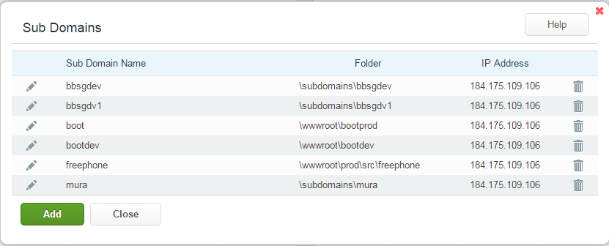

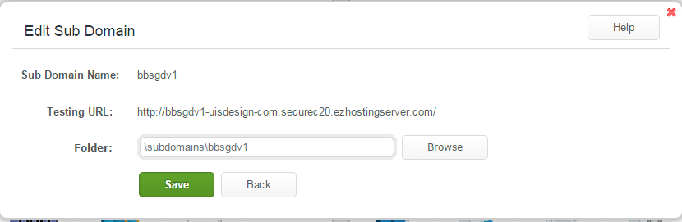

Here is file manager

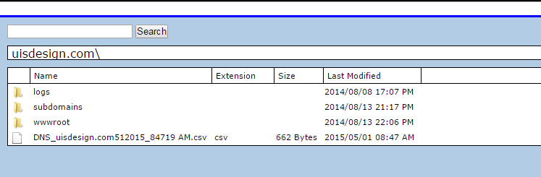

Here are corresponding entries in filezilla, under site manager

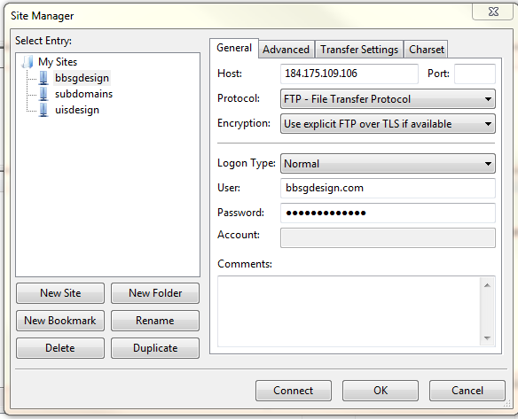

Here is location of development source code, under bbsgdesign connection. Copy stuff from LOCAL C:\ColdFusion11\cfusion\wwwroot to that remote location, except .git, CFIDE and WEB-INF.

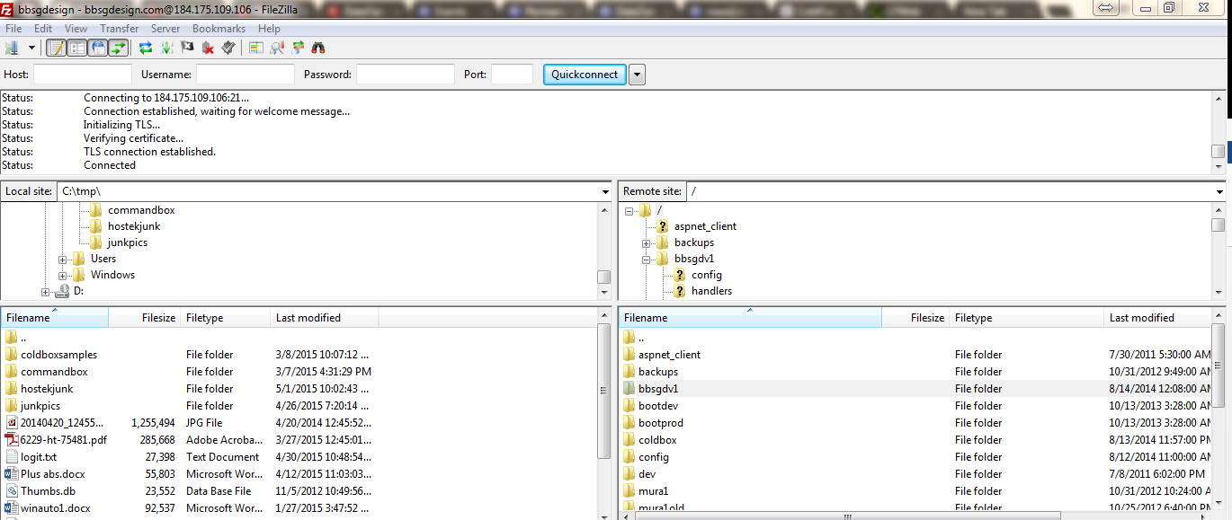

In local copy of MySQL,

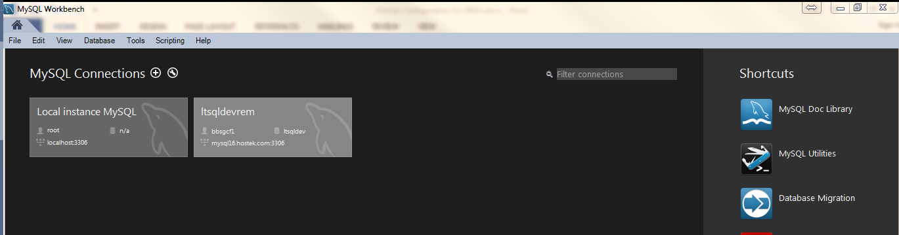

Here is a connection in MySQL Data Migration.

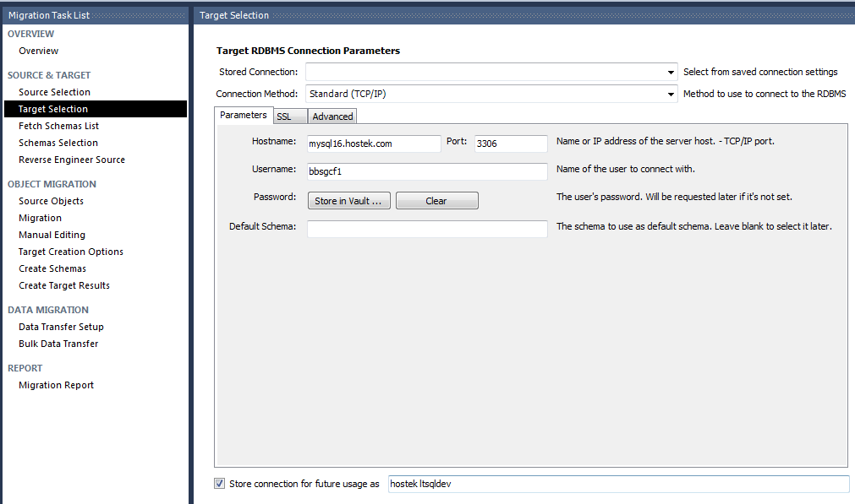ff